**AEM Cloud Installation**:

1. Install Java 11.0.14 version on your system.
2. Install Maven 3.8.6
3. Put setting.xml in .m2 repository. For AEM we need different xml configuration, so we need to change it.
4. Create folder for AEM jar and license file.
5. Click on JAR to start the AEM instance. At very first time it will take time. You can browse on port 4502.
6. To start the AEM in debug mode use this command:

**java -Xdebug -agentlib:jdwp=transport=dt_socket,address=9000,server=y,suspend=n -jar aem-cloud.jar**

**Installation of the code base on AEM:**

1. Go to the folder where the project resides. Open the command prompt.A computer screen with a black screen

   Description automatically generated
2. Use command: **mvn clean install -PautoInstallPackage -Dmaven.test.skip=true**
3. If build is successful, then it’s installed other than you will find some errors.

**Errors:**

1.

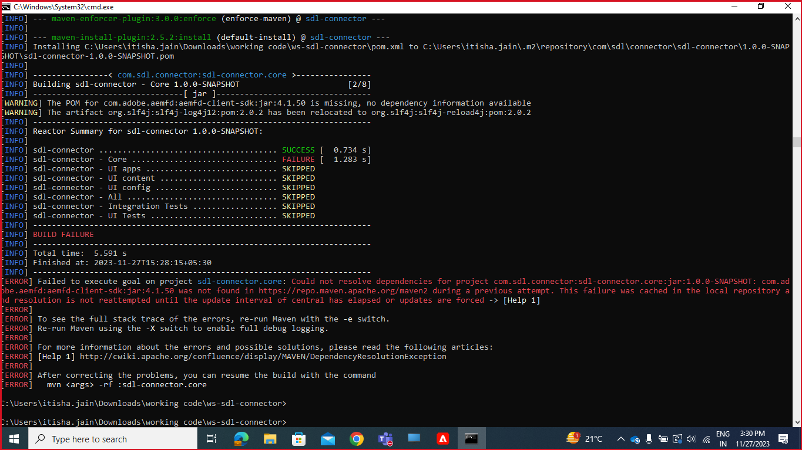

**Solution**: Do not forget to put settings.xml which is useful for AEM only. Check .m2 repository the jar file which is not found is it present or not. If it is not there you have to put it manually or can try again to install all the dependencies again.